|  |  |
| --- | --- |
|  | Department of Information Technology - State Polytechnic of Malang  **Jobsheet-4: PHP**  **Web Design and Programming Courses**  Web Design and Programming Teaching Team  September 2024 |

Muhammad Afif Khosyidzaki_SIB2-G

NIM : 2341760159

GITHUB https://github.com/apip2pipp/P_WEB_JOBSHEET

**Topic**

* Introduction to PHP

**Purpose**

Students are expected to:

1. Students are able to create static websites using PHP

**Introduction**

**What is PHP?**

PHP (PHP: Hypertext Preprocessor) is an open source server-side scripting programming language. As a scripting language, PHP executes programming instructions during runtime. The results of the instructions will certainly differ depending on the data processed. PHP is a server-side programming language, so scripts from PHP will later be processed on the server. Types of servers that are often used in conjunction with PHP include Apache, Nginx, and LiteSpeed. In addition, PHP is also an open source programming language. Users are free to modify and develop according to their needs.

**Why Use PHP?**

Today, no less than 78% of websites around the world use the programming language created by Rasmus Lerdorf in 1995. Even big platforms like Facebook use it.

So, what makes PHP so popular? Why use PHP that's more than two decades old? Here are some reasons:

* **It tends to be easy to learn** — compared to some other popular programming languages, PHP is easier to learn.
* **Abundant learning materials** — the "quite old" age of PHP has led to a lot of documentation, guidance, and active communities scattered around the virtual space. So, there is no need to be afraid if you are having difficulties.
* **PHP is open-source** — anyone can use PHP without spending a dime.
* **High speed** — PHP has been proven to improve loading speed compared to other languages. For example, it is three times faster than Python in some cases.
* **Lots of database options** — PHP can be used in almost any type of database. Starting from MySQL, to non-relational databases such as Redis.
* **Good compatibility with HTML** — PHP scripts don't interfere with HTML at all. Instead, the two of them complement each other.
* **High flexibility —** PHP can be combined with a lot of other programming languages. So you can use it as needed.
* **Multi-platform** — PHP can be used on a variety of operating systems. Starting from Windows, Linux, to MacOS.
* **It's always up to date** — since it first appeared in 1995, PHP is now at version 8.2.4.
* **Supports cloud services** — who would have thought, even though PHP is almost two decades old, it can support cloud services with good scalability.

**PHP Basic Syntax**

Each programming language has its own coding rules. The same goes for PHP. All PHP code written should be stored with .php extension files. The basic syntax opens with <?php and closes with ?> as seen in the following example:

|  |
| --- |
| **<?php**  echo "Welcome";  **?>** |

Description:

* **<?php** : mandatory code to open PHP programs.
* echo : a command to display text.
* "Welcome": the text to be displayed and written between quotation marks and semicolons.
* **?>** is the code to terminate PHP and is mandatory when combined with other programming languages such as HTML.

PHP syntax is **case sensitive**. So, the use of uppercase or lowercase letters will also affect the output given. Example:

|  |
| --- |
| **<?php**  $alamat = "Yogyakarta";  echo $alamat;  **?>** |

The above code will produce the output: **Yogyakarta** on the website page.

However, if it is written like this:

|  |
| --- |
| **<?php**  $alamat = "Yogyakarta";  echo $Alamat;  **?>** |

Then an error will be generated. The reason is that there is a difference between  **the $alamat** and **$Alamat** variables.

In PHP, comments can be written as an explanation of the code. Comments in PHP use or **\*/** and will not be displayed as output in the browser. Examples are as follows:

|  |
| --- |
| **<?php**  Here's an example of using comments  echo "How are you?";  /*  Well this is also an example of a comment  written more than one line  */  **?>** |

**Writing PHP Codes**

Basically, the coding of this programming language is divided into two:

### 1. PHP Native

Native is writing PHP code from scratch when designing a website. PHP Native is often used by developers who have good coding skills or those who want to create unique pipeline frameworks with high functionality.

### 2. PHP Framework

When using a framework, developers can take advantage of ready-made website management frameworks. This means that there is no need to make it from scratch making the work easier. A framework is a framework that can help developers work more efficiently and complete website development faster. Some of the popular PHP frameworks used include: CodeIgniter, Laravel framework, Yii, Symfony and Zend Framework. If you are already proficient in PHP native, it is highly recommended to try switching to the PHP framework. That's because the code in the framework has been optimized according to standards, in terms of speed and security.

### Variables in PHP

Variables are storage places that are used to store data that can change during the course of a program. Variables can be thought of as containers filled with different types of data. Here are a few things you need to know about variables in PHP:

* **Variable Declaration:** the variable is declared with a dollar sign ($) followed by the variable name. For example: **$namaVariabel**.
* **Variable Naming Rules:**  variable names must begin with a letter or underscore ( _ ) and may contain letters, numbers, or underscores. However, there is a difference between case and case sensitive. Examples: **$nama**, **$umur**, **$alamat**.
* **Assignment Value:** a value can be assigned to a variable by using the assignment operator (=). Example: **$nama = "John";**.
* **Data Types:** PHP is a programming language whose data types are dynamic, meaning that there is no need to initialize data types when declaring variables. Variables can store different types of data, such as strings, numbers, booleans, arrays, and others.
* **Accessing Variable Values:**  variable values can be accessed by using their variable names. Example: **$nama**.

Example of implementing a variable script:

* In the form of a string

|  |
| --- |
| **<?php**  $name = "John";  $job = "Programmer";  echo "Hello, my name is $name and I am a $job.";  **?>** |

* In the form of numbers

|  |
| --- |
| **<?php**  $age = 25;  $height = 175.5;  echo "I am $age years old and I am $height cm tall.";  **?>** |

### Constants in PHP

A constant is a fixed value that cannot be changed during the course of the program. They are often used to store values that should not change during the execution of a program. Here are a few things about constants in PHP:

* **Constant Declaration:** Constants are declared using **the define() function**  with two parameters: the name of the constant and its value. Example: **define("PI", 3.14);**.
* **Constant Naming Rules:** Constants are generally written in capital letters and use an underscore (_) as a word separator if the name of the constant consists of several words. Example: **MAX_VALUE**.
* **Constant Data Types:** Constants can also store different types of data, such as strings, numbers, booleans, or arrays. But, once a constant is defined, its value cannot be changed during the program.
* **Accessing Constants:** You can access constants by using the name of the constant. Example: **echo PI;**.

Example of a constant script implementation:

|  |
| --- |
| **<?php**  define("PI", 3.14159265);  $radius = 5;  $area = PI * ($radius * $radius);  echo "The area of a circle with a radius of $radius is $area.";  **?>** |

**Practical Section 1. Variables and Constants**

|  |  |
| --- | --- |
| **Step** | **Description** |
| 1 | Create a new file in the dasarWeb folder and name it variabelkonstanta.php. |
| 2 | Write the following code in the variabelkonstanta.php file |
| 3 |  |
| 4 | Add the contents of the variabelkonstanta.php file with the code below. |
| 5 |  |
| 6 | Add the contents of the variabelkonstanta.php file with the code below. |
| 7 |  |
| 8 | Save the file, then open a browser and run localhost/dasarWeb/variabelkonstanta. |
| 9 | What do you understand from the use of variables on the file? Record your understanding below. (Question No. 1)    these examples illustrate how variables and constants are fundamental to storing and manipulating data in PHP. |

**Data Types in PHP**

A data type is a classification of a type of data or a form of data. There are a wide variety of data types ranging from native data types to artificial data types. PHP supports at least eight scalar data types. The eight types of data are:

|  |  |
| --- | --- |
| **Data Type** | **Description** |
| Integer | Contains whole numbers. |
| Float | Contains decimal numbers. |
| Boolean | Contains only 2 values: true and false. |
| String | Contains text data enclosed by a ''' or " " ' sign. |
| Array | Contains a dataset. |
| Object | Used to create objects from predefined classes. |
| NULL | It is used to state that a variable has no value. |
| Callable | Used to store a reference to a callable function or method. |

**Practicum 2: Use of Data Types**

|  |  |
| --- | --- |
| **Step** | **Description** |
| 1 | Create a new file named tipedata.php. Type the code in step 2 inside the tipedata.php |
| 2 |  |
| 3 | Save the file, then open a browser and run localhost/dasarWeb/tipedata.php |
| 4 | Explain what you understand from the code below. (Question No. 2)  $a is assigned the value 10.  $b is assigned the value 5.  $c is calculated by adding 5 to $a, resulting in 15.  $d is calculated by first multiplying 10 by 5 (which equals 50) and then adding $b (which is 5), resulting in 55.  $e is calculated by subtracting $c (which is 15) from $d (which is 55), resulting in 40.  The echo statements output the values of each variable. The use of {$variable} allows for easy inclusion of variable values within strings, and <br> is used to create line breaks in the HTML output. |
| 5 | Add the contents of the tipedata.php file with the code below. |
| 6 | Save the file, then open a browser and run localhost/dasarWeb/tipedata.php |
| 7 | Explain what you understand from the code below. (Question No. 3)  $nilaiMatematika is set to 5.1.  $nilaiIPA is set to 6.7.  $nilaiBahasaIndonesia is set to 9.3.  The average score ($rataRata) is calculated by summing the three subject scores and dividing by 3. This gives the average score for the subjects The echo statements output the scores for each subject and the average score. The use of curly braces ({$variable}) allows for embedding variable values within strings, and <br> is used for line breaks in the HTML output, var_dump($rataRata); function is called to print detailed information about the average score, including its data type and value. |
| 8 | Add the contents of the tipedata.php file with the code below. |
| 9 | Save the file, then open a browser and run localhost/dasarWeb/tipedata.php |
| 10 | Explain what you understand from the code below. (Question No. 4)  $apakahSiswaLulus: This variable is set to true, indicating that the student has passed.  $apakahSiswaSudahUjian: This variable is set to false, indicating that the student has not taken the exam.var_dump($apakahSiswaLulus);: This function outputs detailed information about the variable $apakahSiswaLulus, including its value (true) and its data type (boolean).  echo "<br>";: This outputs an HTML line break, creating space between the two outputs for better readability.  var_dump($apakahSiswaSudahUjian);: Similar to the first var_dump, this outputs the value (false) and type of $apakahSiswaSudahUjian. |
| 11 | Add the contents of the tipedata.php file with the code below. |
| 12 | Save the file, then open a browser and run localhost/dasarWeb/tipedata.php |
| 13 | Explain what you understand from the code below. (Question No. 5)  $namaDepan: Stores the first name "Ibnu".  $namaBelakang: Stores the last name "Jakaria".  $namaLengkap: Combines the first and last names using double quotes and variable interpolation.  $namaLengkap2: Combines the names using the concatenation operator (.) with a space in between.  echo "Nama Depan: {$namaDepan} <br>";: Outputs "Nama Depan: Ibnu" followed by a line break.  echo 'Nama Belakang: ' . $namaBelakang . '<br>';: Outputs "Nama Belakang: Jakaria" followed by a line break.  echo $namaLengkap;: Outputs the full name "Ibnu Jakaria". |
| 14 | Add the contents of the tipedata.php file with the code below. |
| 15 | Save the file, then open a browser and run localhost/dasarWeb/tipedata.php |
| 16 | Explain what you understand from the code below. (Question No. 6)  echo $listMahasiswa[0];: This line outputs the first element of the array (index 0), which is "Wahid Abdullah"this PHP code snippet demonstrates how to create an array and access its elements. |

**Operators in PHP**

An operator in programming is a symbol or sign used to perform operations on data. Operators are used to perform various actions such as mathematical operations, comparisons, logic, and more on the values present in the program. We use operators in the PHP programming language when it is necessary to perform basic operations such as data manipulation, value comparison, condition evaluation, and various other actions on the values present in the program. Operators make it possible to change, manipulate, or make decisions based on those values.

**Types of Operators in PHP**

Here is a table that contains a list of some of the commonly used operators in PHP

| Operator Type | Symbol | Description and Examples of Use |
| --- | --- | --- |
| Aritmatika | + | Sum: **$hasil = $angka1 + $angka2;** |
|  | – | Subtraction: **$hasil = $angka1 – $angka2;** |
|  | * | Multiply: **$hasil = $angka1 * $angka2;** |
|  | / | Division: **$hasil = $angka1 / $angka2;** |
|  | % | Remainder Divided: **$sisa = $angka1 % $angka2;** |
| Checklists | == | Equal to: **$hasil = $nilai1 == $nilai2;** |
|  | != | Not equal to: **$hasil = $nilai1 != $nilai2;** |
|  | < | Smaller than: **$hasil = $nilai1 < $nilai2;** |
|  | > | Greater than: **$hasil = $nilai1 > $nilai2;** |
|  | <= | Less than or equal to: **$hasil = $nilai1 <= $nilai2;** |
|  | >= | Greater than or equal to: **$hasil = $nilai1 >= $nilai2;** |
| Logic | && / and | AND (dan): **$hasil = $a && $b;** |
|  | || / or | OR (atau): **$hasil = $a || $b;** |
|  | ! / not | NOT (negasi): **$hasil = !$a;** |
| Assignment | = | Typical assignment: **$a = $b;** |
|  | += | Assignment with summation: **$a += $b;** |
|  | -= | Assignment with subtraction: **$a -= $b;** |
|  | *= | Assignment by multiplication: **$a *= $b;** |
|  | /= | Assignment by division: **$a /= $b;** |
|  | %= | Assignment with remainder divided by: **$a %= $b;** |
| Increment/ Decrement | ++ | Increment (menambah 1): **$a++;** |
|  | — | Decrement (mengurangi 1): **$a–;** |
| Bitwise | & | AND bitwise: **$hasil = $a & $b;** |
|  | | | OR bitwise: **$hasil = $a | $b;** |
|  | ^ | XOR bitwise: **$hasil = $a ^ $b;** |
|  | ~ | NOT bitwise: **$hasil = ~$a;** |
| Appointment | ** | Rank: **$hasil = $angka ** $pangkat;** |
| Identik | === | Identical (values and data types are the same): **$hasil = $a === $b;** |
|  | !== | Not Identical (values or data types are not the same): **$hasil = $a !== $b;** |
| Ternary | ? : | Conditional operator (ternary): **$hasil = ($nilai > 10) ? "Bigger" : "Smaller";** |
| Array | [] | Access array elements: **$nilai = $array[0];** |
|  | + | Array merging: **$array 3 = $array 1 + $array 2;** |

**Practical Section 3: The Use of PHP Operators**

|  |  |
| --- | --- |
| **Step** | **Description** |
| 1 | Create a new file named operator.php. Type the code in step 2 inside the operator.php |
| 2 |  |
| 3 | Complete the program code above so that it can display the results and be neat.  (Question No. 7)  $a: Assigned the value 10.  $b: Assigned the value 5.  $hasilTambah: Stores the result of adding $a and $b (10 + 5).  $hasilKurang: Stores the result of subtracting $b from $a (10 - 5).  $hasilKali: Stores the result of multiplying $a and $b (10 * 5).  $hasilBagi: Stores the result of dividing $a by $b (10 / 5).  $sisaBagi: Stores the remainder when $a is divided by $b (10 % 5).  $pangkat: Stores the result of raising $a to the power of $b (10 raised to the power of 5). |
| 4 | Save the file, then open a browser and run localhost/dasarWeb/operator.php . Observe what is happening and explain what you understand. (Question No. 8) |
| 5 | Add the following code to the operator.php |
| 6 | Complete the program code above so that it can display the results and be neat. Save the file, then open a browser and run /refresh localhost/basicWeb/operator.php  Observe what is happening and explain what you understand. (Question No. 9)  ==: Checks for equality.  !=: Checks for inequality.  <: Checks if $a is less than $b.  >: Checks if $a is greater than $b.  <=: Checks if $a is less than or equal to $b.  >=: Checks if $a is greater than or equal to $b.  Each echo statement outputs the result of the comparison.  The ternary operator ? : is used to display "True" if the comparison result is true and "False" if it is false. |
| 7 | Add the code in step 8 on operator.php |
| 8 |  |
| 9 | Complete the program code above so that it can display the results and be neat. Save the file, then open a browser and run /refresh localhost/basicWeb/operator.php  Observe what is happening and explain what you understand. (Question No. 10)    $hasilAnd: Uses the logical AND operator (&&). This will be true only if both $a and $b are true.  $hasilOr: Uses the logical OR operator (||). This will be true if at least one of $a or $b is true.  $hasilNotA: Uses the logical NOT operator (!) on $a. This will invert the value of $a.  $hasilNotB: Uses the logical NOT operator (!) on $b. This will invert the value of $b. |
| 10 | Add the code in step 11 on operator.php |
| 11 |  |
| 12 | Complete the program code above so that it can display the results and be neat. Save the file, then open a browser and run /refresh localhost/basicWeb/operator.php  Observe what is happening and explain what you understand. (Question No. 11)    $a += $b;: Adds $b to $a. After this operation, $a becomes 15.  $a -= $b;: Subtracts $b from $a. After this operation, $a returns to 10.  $a *= $b;: Multiplies $a by $b. After this operation, $a becomes 50.  $a /= $b;: Divides $a by $b. After this operation, $a returns to 10.  $a %= $b;: Calculates the modulus of $a by $b. After this operation, $a becomes 0. |
| 13 | Add the code in step 14 on operator.php |
| 14 |  |
| 15 | Complete the program code above so that it can display the results and be neat. Save the file, then open a browser and run /refresh localhost/basicWeb/operator.php  Observe what is happening and explain what you understand. (Question No. 12)    $hasilIdentik: Uses the identical operator (===). This checks if $a is identical to $b, meaning both the value and the type must be the same. In this case, since $a is an integer and $b is a string, the result is false.  $hasilTidakIdentik: Uses the non-identical operator (!==). This checks if $a is not identical to $b. Since they are not the same type, the result is true. |
| 16 | **Question**: A restaurant has 45 seats in it. On one night, 28 seats were occupied by customers. What percentage of seats are still empty in the restaurant? |
| 17 | Create a file with named latihanoperator.php. Write down the program code for step 16 and display the result below along with the program code (Question No. 13)    <?php  $totalSeats = 45;  $occupiedSeats = 28;  $emptySeats = $totalSeats - $occupiedSeats;  $percentageEmpty = ($emptySeats / $totalSeats) * 100;  echo "Total Seats: $totalSeats<br>";  echo "Occupied Seats: $occupiedSeats<br>";  echo "Empty Seats: $emptySeats<br>";  echo "Percentage of Empty Seats: " . round($percentageEmpty, 2) . "%<br>"; |

**Control Structure In PHP**

Basically, programming is about controlling the execution flow of a program. A control structure is a tool used to decide how code will be executed based on certain conditions.

**Conditional Statement**

Conditional statements are used to make decisions based on certain conditions. There are several types of conditional statements in PHP:

* **if**: Used to execute a block of code if certain conditions are true.

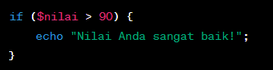

* **else**: Used in conjunction with **if** to execute a block of code if the condition is incorrect.

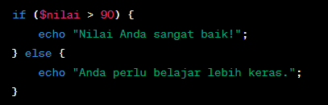

* **elseif**: Used to add additional conditions after **if**.

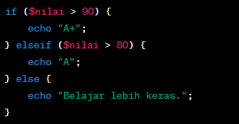

* **switch**: Used to evaluate expressions and execute code based on matching values.

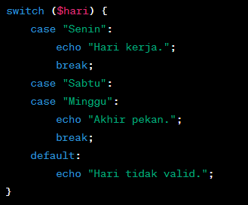

**Looping**

Looping allows you to iterate through the code multiple times based on certain conditions. There are three types of loops that are most commonly used in PHP:

* **for**: Used to repeat the code a certain number of times.

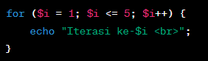

* **while**: Used to repeat code as long as a certain condition is true.

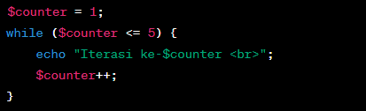

* **do-while**: Similar to **while**, but will execute a block of code at least once before checking for conditions.

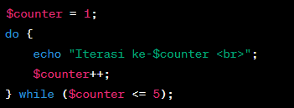

**Flow Control Statement**

This statement allows you to control the flow of program execution in a certain way:

* **break**: Used to stop the current loop or switch.

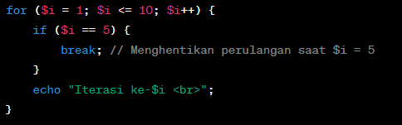 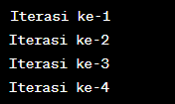

* **continue**: Used to resume the next iteration in the loop.

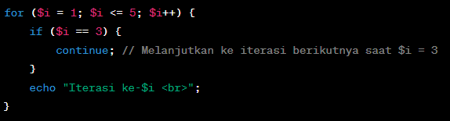 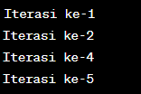

**Practical Section 4: The Use of Control Structures in PHP**

|  |  |
| --- | --- |
| **Step** | **Description** |
| 1 | Create a new file named strukturkontrol.php. Type the code in step 2 inside the strukturkontrol.php |
| 2 |  |
| 3 | Save the file, then open a browser and run /refresh localhost/dasarWeb/strukturkontrol.php |
| 4 | Note here what you observe from the addition of the program code above. (Question No. 14)    The code checks the value of $nilaiNumerik against several conditions to determine the corresponding letter grade:  If the value is between 90 and 100, it outputs "Nilai huruf: A".  If the value is between 80 and 89, it outputs "Nilai huruf: B".  If the value is between 70 and 79, it outputs "Nilai huruf: C".  If the value is below 70, it outputs "Nilai huruf: D". |
| 5 | Add the code in step 6 in strukturkontrol.php |
| 6 |  |
| 7 | Complete the program code above so that the result is neat. Save the file, then open a browser and run /refresh localhost/dasarWeb/strukturkontrol.php |
| 8 | Note here what you observe from the addition of the program code above. (Question No. 15)    $jarakSaatIni: Initializes the current distance to 0.  $jarakTarget: Sets the target distance to 500.  $peningkatanHarian: Defines the daily increase in distance to 30.  $hari: Initializes the day counter to 0.  The loop continues as long as the current distance ($jarakSaatIni) is less than the target distance ($jarakTarget).  Inside the loop, the current distance is increased by the daily increment ($peningkatanHarian), and the day counter ($hari) is incremented by 1. |
| 9 | Add the code in step 9 inside the strukturkontrol.php |
| 10 |  |
| 11 | Complete the program code above so that the result is neat. Save the file, then open a browser and run /refresh localhost/dasarWeb/strukturkontrol.php |
| 12 | Note here what you observe from the addition of the program code above. (Question No. 16)    $jumlahLahan: Sets the number of plots to 10.  $tanamanPerLahan: Defines the number of plants per plot to 5.  $buahPerTanaman: Sets the number of fruits per plant to 10.  $jumlahBuah: Initializes the total number of fruits to 0.  The loop iterates from 1 to the total number of plots ($jumlahLahan).  In each iteration, it calculates the total number of fruits produced by multiplying the number of plants per plot by the number of fruits per plant, and adds this to $jumlahBuah. |
| 13 | Add the code in step 14 inside the strukturkontrol.php |
| 14 |  |
| 15 | Complete the program code above so that the result is neat. Save the file, then open a browser and run /refresh localhost/dasarWeb/strukturkontrol.php |
| 16 | Note here what you observe from the addition of the program code above. (Question No. 17)    $skorUjian: An array that contains the scores of the exams.  $totalSkor: Initializes the total score to 0.  he loop iterates through each score in the $skorUjian array.  In each iteration, it adds the current score ($skor) to the total score ($totalSkor). |
| 17 | Add the code in step 18 inside the strukturkontrol.php |
| 18 |  |
| 19 | Complete the program code above so that the result is neat. Save the file, then open a browser and run /refresh localhost/dasarWeb/strukturkontrol.php |
| 20 | Note here what you observe from the addition of the program code above. (Question No. 18)    $nilaiSiswa: An array that contains the scores of the students,The loop iterates through each score in the $nilaiSiswa array, If the score ($nilai) is less than 60, it outputs that the student did not pass and continues to the next iteration. |
| 21 | **Question**: A teacher wants to calculate the total score of 10 students in a math exam. This teacher wanted to ignore the two highest grades and the two lowest grades. Help this teacher calculate the total grades that will be used to determine the average grade after ignoring the highest and lowest grades. The following is a list of grades from 10 students (85, 92, 78, 64, 90, 75, 88, 79, 70, 96) |
| 22 | Create a file with the name kontrol1.php. Create the program code for step 21 and display the result below along with the program code (Question No. 19)    <?php  $grades = [85, 92, 78, 64, 90, 75, 88, 79, 70, 96];  sort($grades);  array_shift($grades);  array_shift($grades);  array_pop($grades);  array_pop($grades);  $totalGrades = array_sum($grades);  $averageGrade = $totalGrades / count($grades);  echo "Total grades after ignoring the highest and lowest: $totalGrades <br>";  echo "Average grade: $averageGrade <br>";  ?>  An array $grades contains the scores of 10 students.The sort() function sorts the grades in ascending array_shift() is used twice to remove the two lowest grades. array_pop() is used twice to remove the two highest grades. order.array_sum() calculates the total of the remaining grades.  The average is calculated by dividing the total by the count of the remaining grades.  The total and average grades are displayed using echo. |
| 23 | There is a story: A customer wants to buy a product at a price of Rp 120,000. The store offers a 20% discount for purchases above IDR 100,000. Help these customers to calculate the price to be paid after getting the discount. |
| 24 | Create a file with the name kontrol2.php. Create the program code for step 23 and display the result below along with the program code (Question No. 20)    <?php  $originalPrice = 120000;  $discountPercentage = 20;  $discountAmount = ($discountPercentage / 100) * $originalPrice;  $finalPrice = $originalPrice - $discountAmount;  echo "Original Price: Rp " . number_format($originalPrice, 0, ',', '.') . "<br>";  echo "Discount: " . $discountPercentage . "%<br>";  echo "Discount Amount: Rp " . number_format($discountAmount, 0, ',', '.') . "<br>";  echo "Final Price to be Paid: Rp " . number_format($finalPrice, 0, ',', '.') . "<br>";  ?>  variable $originalPrice holds the original price of the product, discount percentage is stored in $discountPercentage.discount amount is calculated by multiplying the original price by the discount percentage (converted to a decimal).The final price is computed by subtracting the discount amount from the original price, number_format() function is used to format the prices for better readability (using commas as thousands separators).  The original price, discount percentage, discount amount, and final price are displayed using echo. |
| 25 | **Question:** A gamer wants to calculate their total score in the game. They get a score based on the points they collect. If they have more than 500 points, then they will get additional rewards. Create the first line of "Player's total score is: (**points**)". And the second line "Do players get additional rewards? (**YES/NO**)" |
| 26 | Create a file with the name kontrol3.php. Create the program code for step 25 show the result below along with the program code (Question No. 21)    <?php  $totalPoints = 650;  echo "Player's total score is: $totalPoints <br>";  if ($totalPoints > 500) {  echo "Do players get additional rewards? (YES) <br>";  } else {  echo "Do players get additional rewards? (NO) <br>";  }  ?>  The variable $totalPoints holds the total points collected by the player. You can modify this value to test different scenarios. first line outputs the player's total score using echo.An if statement checks if the player's points exceed 500. If true, it outputs "YES" for additional rewards; otherwise, it outputs "NO". |

**Practical Section 5: Using Arrays in PHP**

### One-Dimensional Array

A one-dimensional array is a data structure that is used to store a number of values in a single variable. You can declare a one-dimensional array in PHP using several methods:

#### Method 1: Using array()



#### Method 2: Using square brackets [] (Starting from PHP 5.4+)



To access the values in the array used indexes (starting from 0 for the first index):



You can add a value to an array using a specific index or by the **[]** method to add a new value to the end of the array:



You can change the values in an array by accessing its index and replacing it:



You can iterate through all the elements in the array using **for**, **foreach**, or **while** loops. Here's an example with **foreach**:

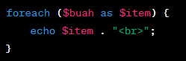

### Two-Dimensional Array

A two-dimensional array is a data structure used to store data in the form of a two-dimensional table, which is similar to rows and columns in a spreadsheet. Here is a brief explanation of two-dimensional arrays and examples of their implementation in PHP:

### 1. Two-Dimensional Array Declaration

You can declare a two-dimensional array in PHP by composing a one-dimensional array in another array:

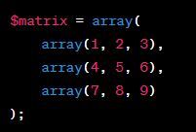

You can also use the square bracket **syntax [][]**:

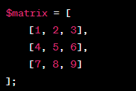

### 2. Accessing Values in a Two-Dimensional Array

You can access values in a two-dimensional array by using two indexes, one for rows and one for columns:



### 3. Adding and Changing Values in a Two-Dimensional Array

You can add or change values in a two-dimensional array by accessing elements using an index:



### 4. Iteration Through Two-Dimensional Arrays

You can iterate through all elements in a two-dimensional array using nested loops, such as loop **for**:

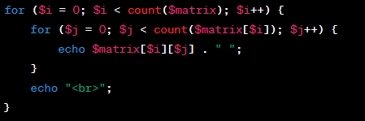

This will print the entire element in a two-dimensional array, resulting in a table-like appearance.

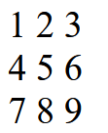

### Multidimensional Array

A multidimensional array is a data structure that allows you to store data in more than two dimensions. This is an expansion of the two-dimensional array described earlier.

### 1. Three-Dimensional Multidimensional Array Declaration

You can declare a three-dimensional multidimensional array by adding an array within an array:

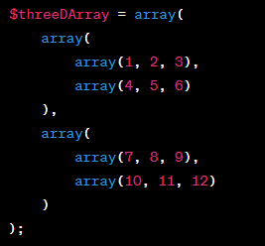

This is an example of a three-dimensional array. You can also use the square bracket syntax **[][][]**:

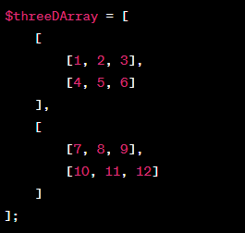

### 2. Accessing Values in a Three-Dimensional Multidimensional Array

You can access values in a three-dimensional multidimensional array by using three indexes, each for the corresponding dimension level:



### 3. Adding and Changing Values in a Three-Dimensional Multidimensional Array

You can add or change values in a three-dimensional multidimensional array by accessing elements using an index:



### 4. Iteration Through Three-Dimensional Multidimensional Arrays

To iterate through a three-dimensional multidimensional array, you need to use three levels of nested loops:

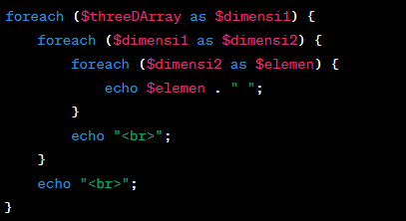

In the example above, we use a three-level nested loop to access all the elements in a three-dimensional array and print them.

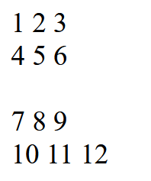

### Associative Array

An associative array is a type of array in PHP that uses a pair of "keys" and "values" to organize data. Here is an explanation and example of implementing associative arrays in PHP:

### 1. Associative Array Declaration

You can declare associative arrays by using **the array()** syntax or square **brackets [].** Each element of an associative array has a key that pairs with its value. Here's an example of using associative arrays in PHP:

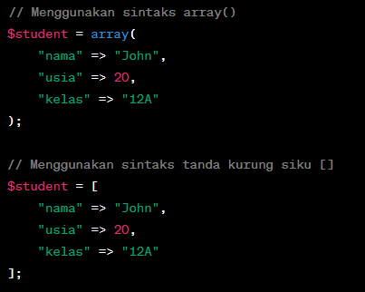

### 2. Accessing Values in Associative Arrays

You can access the values in an associative array by using the appropriate key:

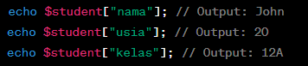

### 3. Adding and Changing Values in Associative Arrays

You can add or change values in an associative array by accessing elements using keys:



### 4. Iteration Through Associative Arrays

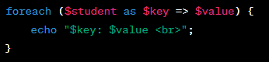

The output of the loop above will print all key-value pairs in the associative array.

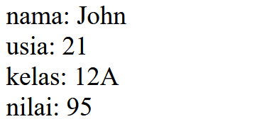

|  |  |
| --- | --- |
| **Step** | **Description** |
| 1 | Create a new file named array.php. Type the code in step 2 inside the array.php |
| 2 |  |
| 3 | Save the file, then open a browser and run /refresh localhost/dasarWeb/array.php |
| 4 | Note here what you observe from adding the code above. (Question No. 22) |
| 5 | Type the additional code in step 6 inside the array.php |
| 6 |  |
| 7 | Save the file, then open a browser and run /refresh localhost/dasarWeb/array.php |
| 8 | Note here what you observe from the addition of the code above. (Question No. 23) |
| 9 | Type the additional code in step 10 inside the array.php |
| 10 |  |
| 11 | Save the file, then open a browser and run /refresh localhost/dasarWeb/array.php |
| 12 | Note here what you observe from the addition of the program code above. (Question No. 24)    <?php  $nilaiSiswa = [85, 92, 78, 64, 90, 55, 88, 79, 70, 96];  $nilaiLulus = [];  foreach ($nilaiSiswa as $nilai) {  if ($nilai >= 70) {  $nilaiLulus[] = $nilai;  }  }  echo "Daftar nilai siswa yang lulus: " . implode(', ', $nilaiLulus);  ?>  initialization: The array $nilaiSiswa contains the scores of students.  Loop: The script uses a foreach loop to go through each score.  Condition: It checks if the score is 70 or higher.  Storing Passing Scores: If a score meets the condition, it is added to the $nilaiLulus array.  Output: Finally, the script prints the list of passing scores in a readable format. |
| 13 | **Question**: A teacher wants to print a list of students' grades in a math exam. The teacher has data on each student consisting of names and grades. Help this teacher print a list of students who achieved grades above the class average. With the provision that the student's name and grade Alice can get 85, Bob can get 92, Charlie can get 78, David can get 64, Eva can get 90 |
| 14 | Create the code for step 13 with a two-dimensional array and display the result below along with the program code (Question No. 25)  <?php  $students = [  ['name' => 'Apip', 'grade' => 85],  ['name' => 'budi', 'grade' => 92],  ['name' => 'aleg', 'grade' => 78],  ['name' => 'riki', 'grade' => 64],  ['name' => 'reji', 'grade' => 90],  ];  $totalGrades = 0;  $numStudents = count($students);  foreach ($students as $student) {  $totalGrades += $student['grade'];  }  $classAverage = $totalGrades / $numStudents;  echo "Class Average: " . number_format($classAverage, 2) . "\n";  echo "Students with grades above the class average:\n";  foreach ($students as $student) {  if ($student['grade'] > $classAverage) {  echo $student['name'] . ": " . $student['grade'] . "\n";  }  }  ?>  Two-Dimensional Array: The $students array holds each student's name and grade.  Total Calculation: The program calculates the total of all grades and the average.  Comparison: It then compares each student's grade against the class average and prints those who scored above it. |